Brian Stewart

Ibm’s Applied Data Science Capstone

Battle of the Neighborhoods

# Introduction

With COVID-19 throwing the economic world into a frenzy many small businesses, and large corporate ones for that matter, have either filed for bankruptcy or closed their doors for good. Unfortunate as this is, up and coming entrepreneurs will face an unprecedented market of corporate real estate for new businesses. Restaurants, Bars/Pubs, Cafes, etc. will have an opportunity to open in prime areas for foot traffic and income when the world returns to normalcy or creates a new normalcy after the COVID-19 threat has subsided. Analysis on neighborhoods and current establishments to find an ideal storefront will become ever important in the coming months and years. This data will be invaluable to new start-ups and can assist them in getting the right patronage and make sure that their business income will be consistent. It will take the guess work out of where to open a business.

New York City (NYC) is one of the busiest and most lucrative cities in the entire world for business. The previously mentioned commercial real estate market is one of the most contentious because of it. Ranging anywhere from 50 to over 200 U.S. dollars per square foot can cause rent prices and mortgages to skyrocket for even a small brick and mortar venue. That is why picking the most ideal real estate is a pivotal part of setting up shop, so to speak, in NYC. There needs to be a guarantee that a business will not lose too much profit to rent and upkeep of an NYC storefront.

# Business Problem

Craft Beer has become an ever-expansive market and is especially popular with 22-35-year-old males, but the female market is growing as well. Currently it accounts for 13.2% of all US beer volumes and has a 24.1% market share at about 27.6 billion US Dollars. That number continues to grow at about 7% a year. With that growth rate it is a very lucrative business to be involved in and now is better time than any to open a microbrewery. My client, a brewer from the Tri-State area, was looking at the commercial real estate in NYC because it ranks fourth in the country for craft breweries and there are many neighborhoods that look enticing for a new brewery.[1]

As an entrepreneur my client has expressed interest in the NYC area for his new craft brewery, pub/lounge, but he wants to pick the right neighborhood for this establishment. With that problem we can assess the things required for his business venture, he will need a middle to upper class neighborhood or borough and an area where there are few other establishments like his but not completely devoid of other establishments. He would like a list of potential neighborhoods for his new start up that fit his criteria so he can start looking for open corporate real estate.

# Data and Methodology

I was able to procure the median household income for each borough and neighborhood in NYC from <https://www.renthop.com/study/assets/new-york-city-cost-of-living-2017/nyc-2br-median-rent-and-income-table.html>. I will then gather the longitude and latitude of each neighborhood. From there I will run a K-Means test to group like neighborhoods and look for those that fit the 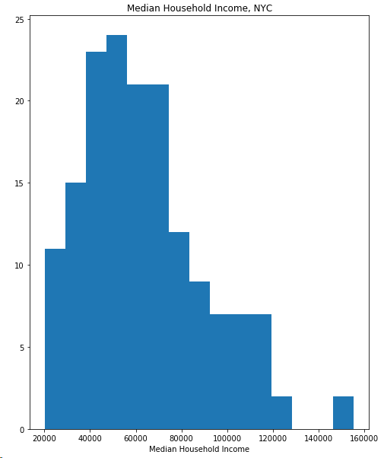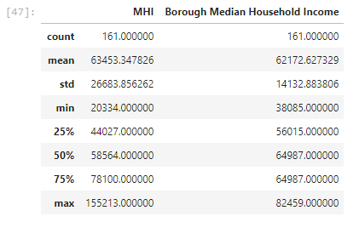household income requirements set by the client (60K+). As shown by Figure A and Table A, the histogram of median household income skews right but the center is around 60K which creates the cutoff point. A new dataset will be created to only include the neighborhoods that fit the middle to upper class household incomes. Then the Foursquare API will be utilized to find the current percentages of venues in the neighborhoods that seem the most promising and from there analyze which neighborhoods would be ideal for my client. The API will provide the information regarding the top business types in each neighborhood which will allow me to figure out where a craft beer pub and lounge would be best suited to get the right consistent patronage. For instance, the Upper West Side of Manhattan has a median income of ~92K making it an ideal neighborhood based on that variable, but after some analysis the top two establishments in the neighborhood are wine bars and bars making the share of the bar market very small for my client which would disqualify it from being considered.

**Figure A**

**Table A**

# Results

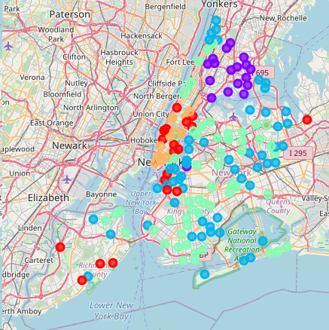The initial k-means test grouped the lower income areas in purple and teal, the middle-class areas in blue, upper middle class in red, and upper class in orange as shown in Map A. This gives us a good spread of potential spots for the venue for the client across all five boroughs. That is important because it will give the client a myriad of locations that all fit his demographic requirements. Map B shows the second k-means groupings after selecting the neighborhoods based on 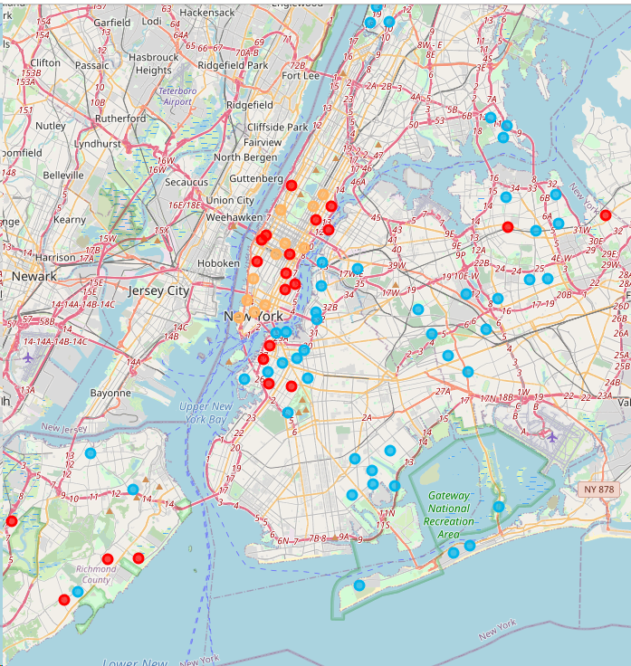the 60K+ requirement set out by the client. Judging by the clustering of the data cluster 4 (Orange) seems to be the best markets for my client. The median income is far above what the client requested, and bars rank low on frequency; that includes cocktail, and wine bars. So, opening a new craft beer bar and lounge in any of the areas in cluster 4 would be a good investment for my client. Each neighborhood also has a good diversity of other establishments where it is not just a bunch of parks or other open areas with little else in the vicinity. The other clusters have bars rank 4th or higher on the frequency in the neighborhoods which means my client’s share of the patron pie would be smaller than that of cluster 4. This would make him more likely to be in the black and offset the higher rent that comes with the neighborhoods in Manhattan which is exclusively where cluster 4 is located.

**Map A**

**Map B**

# Conclusion

Further investigation could be done to understand the commercial rents of each area as well, but I was unable to procure that data. That data would allow me to assess the monthly revenue the client would need to make to have a profit in each neighborhood that would fit his requirements. Another piece of data I was unable to obtain but could be beneficial to this analysis would be the age range of each neighborhood i.e. what the median age is. Most craft beer drinkers are around 22-34 years old so finding neighborhoods with large populations of that age group would also be ideal.

1. beveragedaily.com, “Craft Brewing Contributes $79bn a Year to US Economy,” beveragedaily.com, accessed June 2, 2020, <https://www.beveragedaily.com/Article/2019/10/01/Craft-beer-industry-contributes-79bn-a-year-to-US-economy>.